Project Design Phase
Problem – Solution Fit

Date | 09 February 2026
Team ID | LTVIP2026TMIDS66236
Project Name | Explore With Ai: Custom Itineraries For Your Next Journey
Maximum Marks | 2 Marks

Problem – Solution Fit:
The Problem–Solution Fit for Explore with AI focuses on addressing the common challenges faced by travelers in planning personalized trips efficiently and without stress.
Purpose:
❑ To solve the problem of time-consuming and manual travel planning by providing an AI-powered automated solution.
❑ To improve solution adoption by aligning with modern user behavior, where users prefer quick, web-based, and personalized digital tools.
❑ To clearly communicate the value of AI-driven itinerary generation as a faster and more efficient alternative to traditional travel planning methods.
❑ To reduce frequent user frustrations such as scattered travel information, lack of personalization, and repetitive research efforts.
❑ To understand traveler needs and improve the planning experience by delivering structured, day-wise, and customized travel itineraries.

Template:
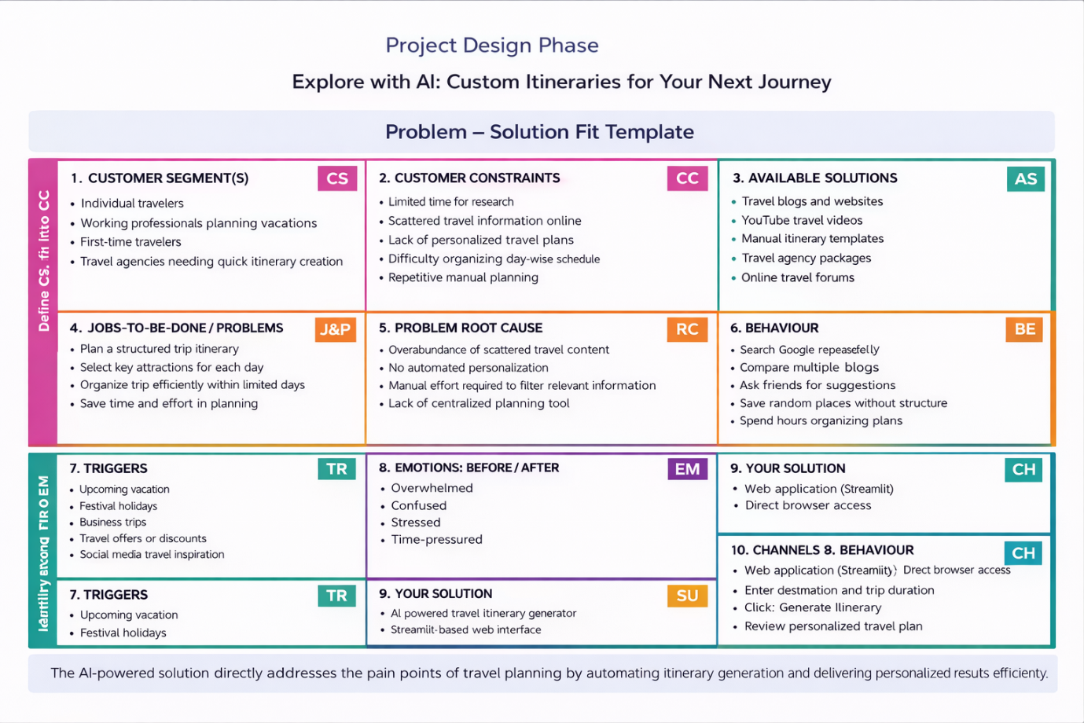
References:
- https://www.ideahackers.network/problem-solution-fit-canvas/
- https://medium.com/@epicantus/problem-solution-fit-canvas-aa3dd59cb4fe

